For slave-1 and job-1
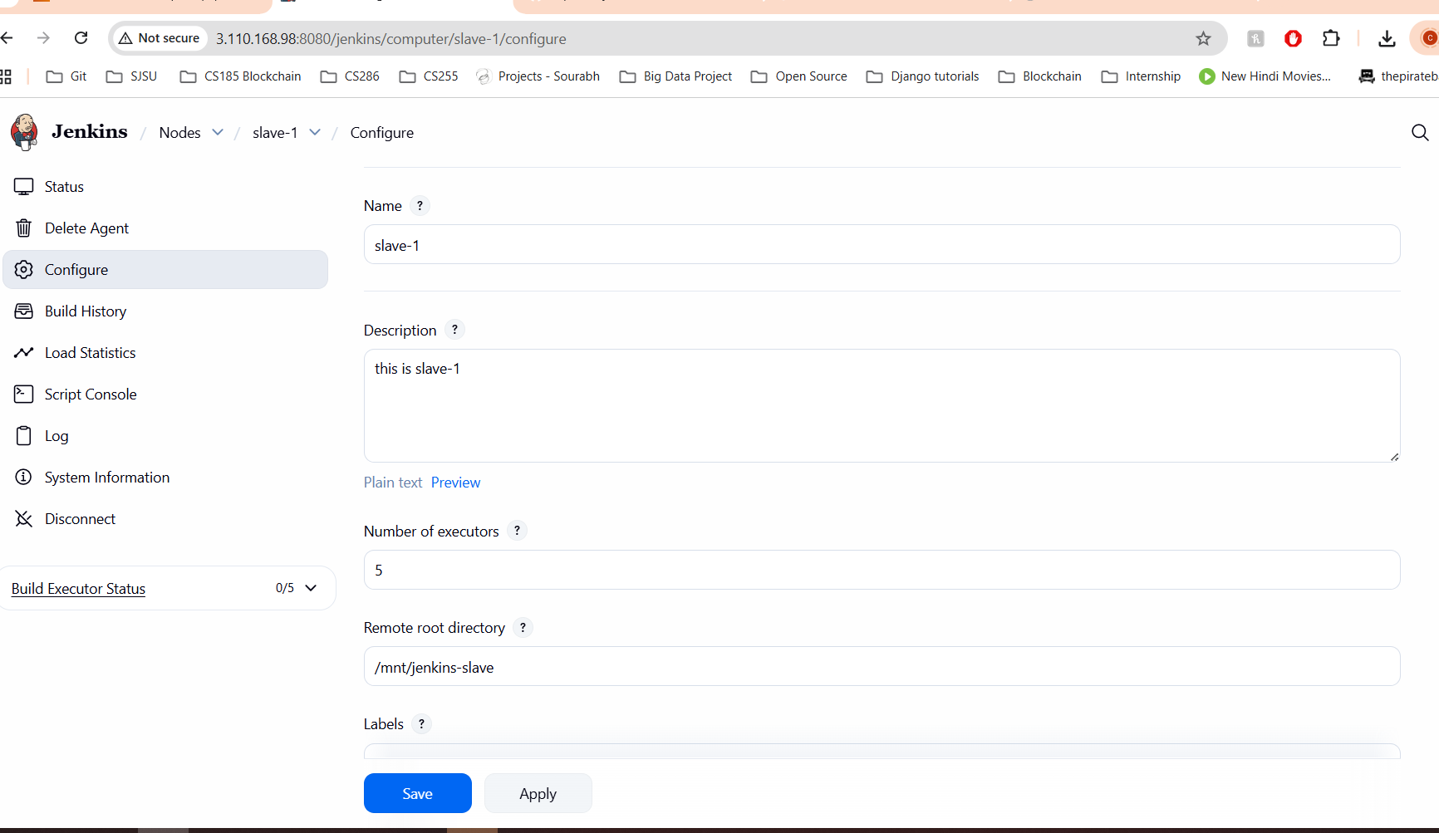
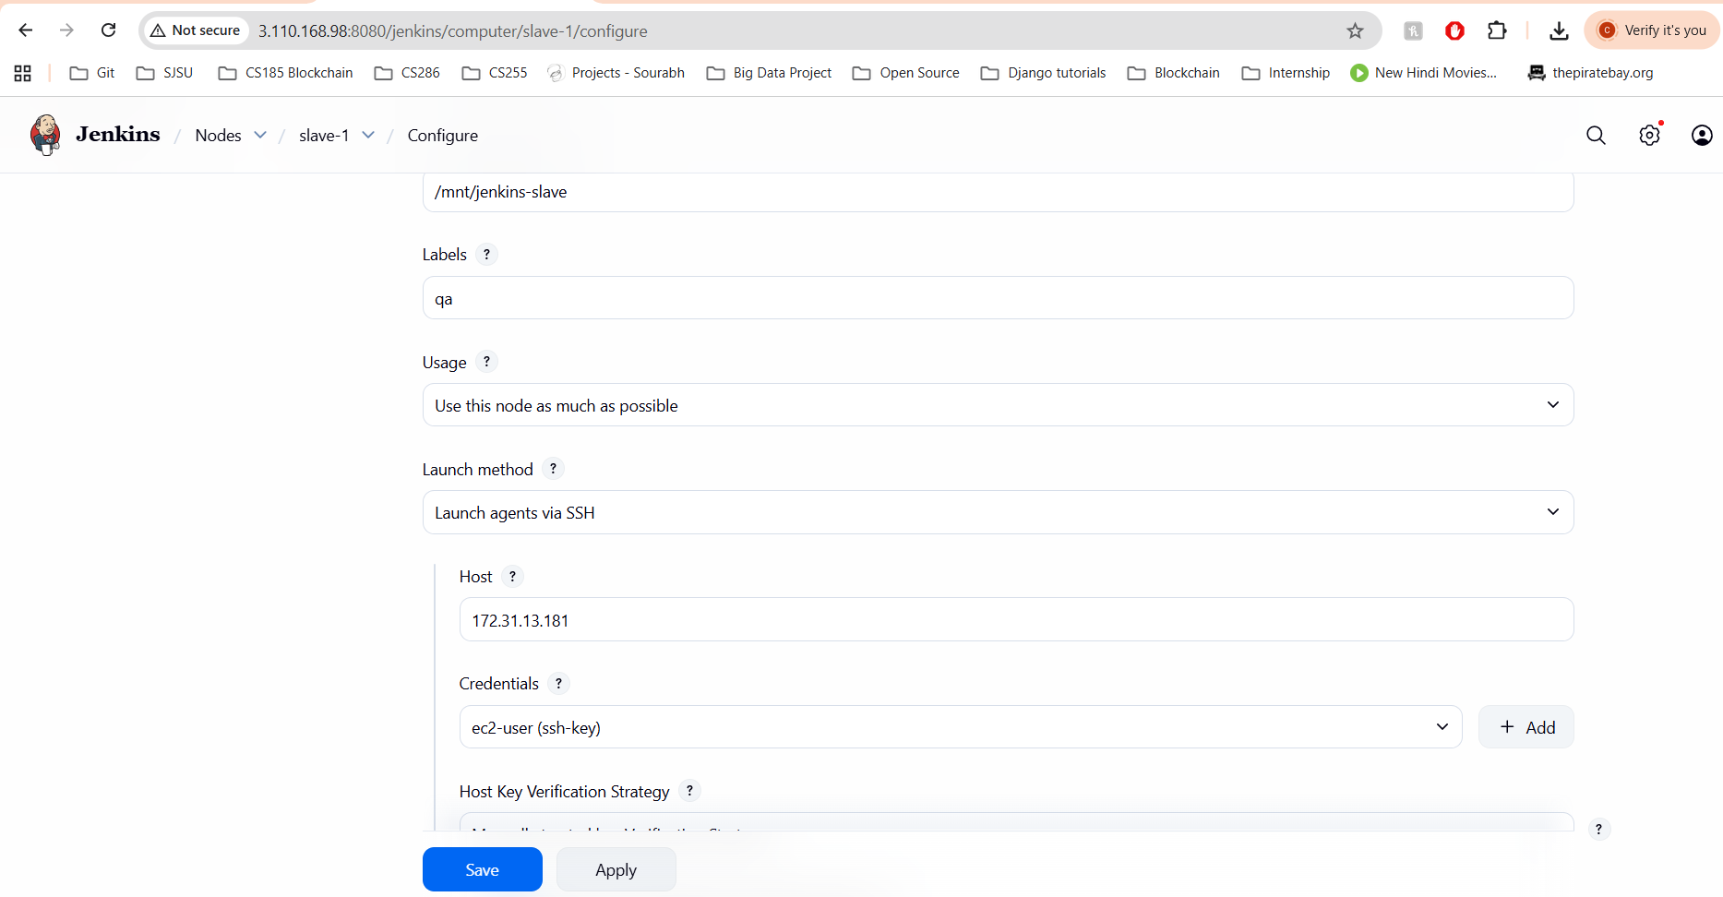

For job-1

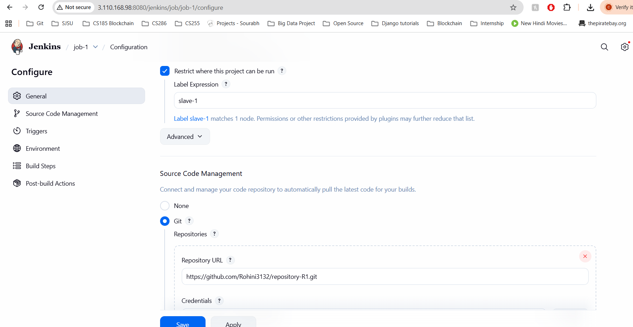

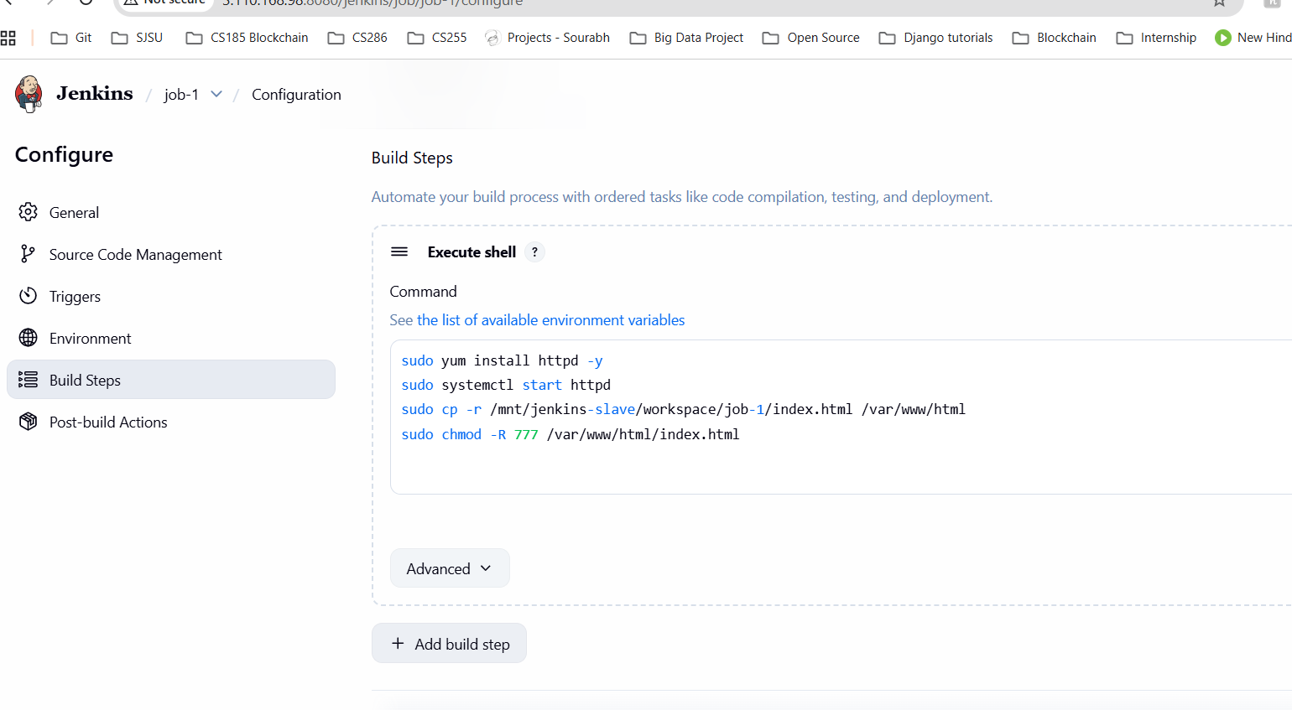

I already confirms all setting of webhook for repo-1
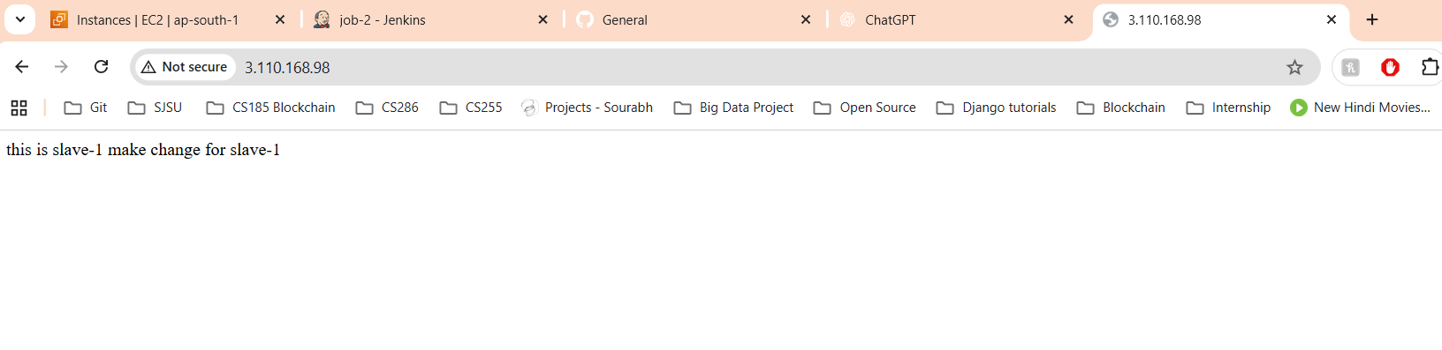
Doing same steps for job-2 ,slave-2
For slave2 only change the host ip as 13.201.132.140

